Celebrating Marriage

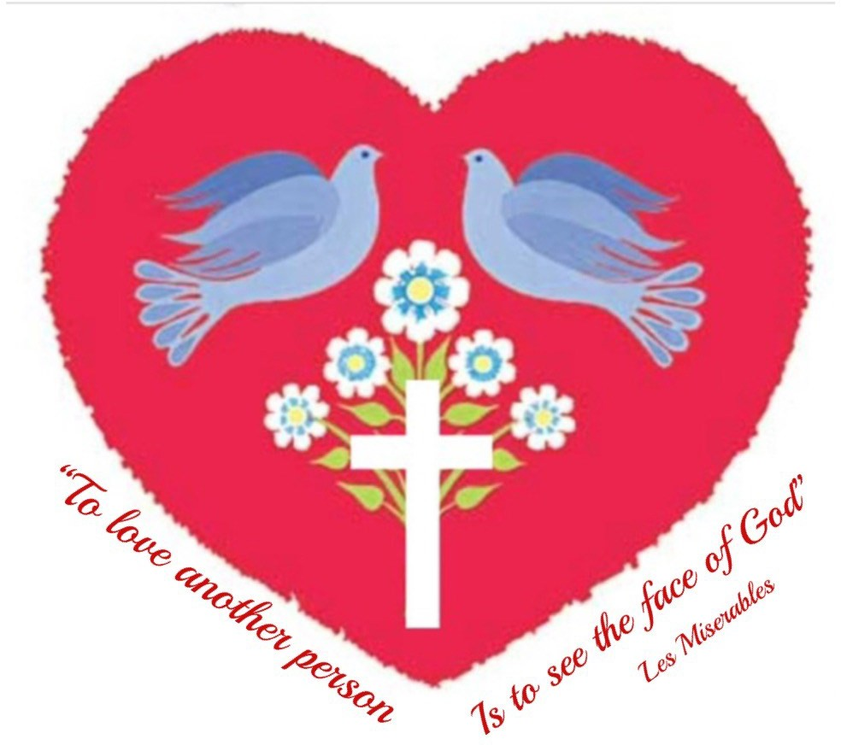

SAVE THE DATE!

Thursday, May 22nd, 2025

When**:** Thursday May 22nd 2025 Time**:** 7.30pm

Where**:** St. Cronan’s Church,

Crusheen

*Come celebrate your marriage*

10th, 25th, 50th, 60th anniversary or any year in between.

**Celebration and Blessing by Bishop Fintan**

To register, please contact Imeall Bóirne Parish Office

Tel: 065 6827018 email: [admin@imeallboirneparish.ie](mailto:info@ennisparish.com)